National University of Technology

Computer Science Department
Fall Semester - 2024
Project
Course: Artificial Intelligence
Submitted To Group Members:
Name: Mam Noushin Saba Muhammad Zaheer (F23605043)
CS-A 2023 Muhammad Shoaib Khan (F23605012)
Muhammad Moazzan (F23605016)
Abdullah Iftikhar (F23605042)
Disease Prediction and Precaution Suggestion System
1. Introduction
This project aims to predict diseases based on user-provided symptoms and suggest appropriate precautions to mitigate health risks. The system uses a structured dataset containing diseases, their associated symptoms, and recommended precautions. By entering symptoms into an interactive GUI, users can receive instant feedback on potential diseases and suggestions for managing their health.
2. Dataset Description
The system uses two datasets:
- Disease Dataset: Contains information about diseases and their associated symptoms.
  - Number of Records: (4922)
  - Columns:
    - Disease: Name of the disease.
    - Symptom_1 to Symptom_17: Symptoms associated with the disease.
- Precaution Dataset: Contains precautionary measures for each disease.
  - Number of Records: (42)
  - Columns:
    - Disease: Name of the disease.
    - Precaution_1 to Precaution_4: Specific precautions for the disease.
Preprocessing Steps:
- Ensured column names and data formats were consistent.
- Checked for missing values in symptom and precaution columns and addressed them appropriately.
- Normalized symptom names for uniformity (e.g., converting to lowercase).
3. Methodology
Process Overview:
- Input: Users provide a list of symptoms through a Tkinter-based graphical user interface (GUI).
- Processing:
  - The input symptoms are matched against the dataset.
  - If the symptoms match a disease entry, the associated precautions are retrieved.
- Output: Predicted disease and a list of suggested precautions are displayed to the user.
Implementation Details:
- Tools and Libraries:
  - tkinter: For creating the GUI.
  - pandas: For data manipulation and analysis.
  - messagebox: To handle error messages.
- Code Logic:
  - Symptoms entered by the user are processed as a list.
  - The system iterates through the dataset to find matching entries.
  - If a match is found, the disease and associated precautions are displayed.
  - Error handling ensures the system provides meaningful feedback for unmatched symptoms or missing datasets.
4. Results
System Output:
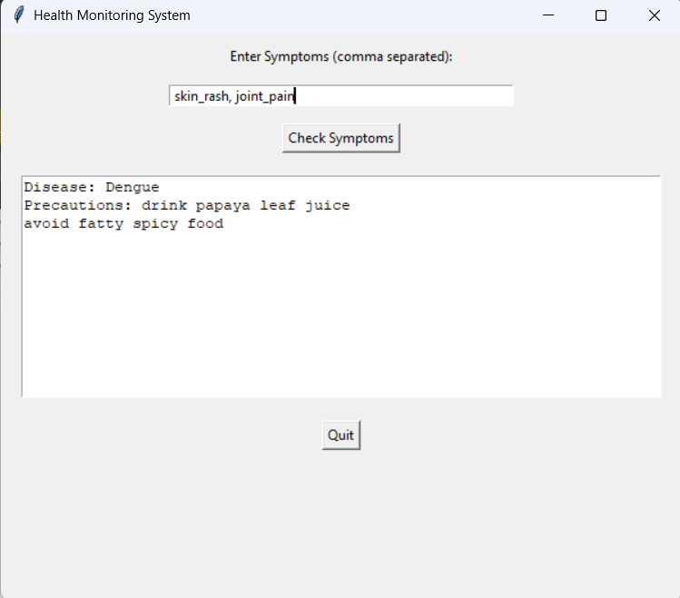
5. Challenges and Limitations
Challenges:
- Handling symptoms that map to multiple diseases.
- Inconsistent or incomplete data in the dataset.
Limitations:
- Relies on exact symptom matches; cannot predict diseases based on approximate or similar symptoms.
- Limited scope of diseases and precautions in the dataset.
6. Conclusion
The project successfully predicts diseases and provides precautionary measures based on user-input symptoms. It demonstrates the utility of combining structured data and a user-friendly interface for health monitoring.
Future Improvements:
- Expand the dataset to include more diseases and symptoms.
- Implement a machine learning model for more accurate predictions.
- Enhance the GUI for a better user experience, including voice input or multilingual support.
7. Appendix
Python Code:

import tkinter as tk
import pandas as pd
from tkinter import messagebox

# Load the datasets using pandas
def load_data():
try:
# Load the disease and precaution CSV files into pandas DataFrames
diseases_df = pd.read_csv(r'Z:\Datasets\dataset.csv')
precautions_df = pd.read_csv(r'Z:\Datasets\symptom_precaution.csv')
return diseases_df, precautions_df
except FileNotFoundError as e:
messagebox.showerror("Error", f"Dataset not found: {e.filename}")
return None, None

# Function to get disease and precaution advice based on symptoms
def get_advice_from_dataset(symptoms):
advice_output = ""
diseases_df, precautions_df = load_data()

if diseases_df is not None and precautions_df is not None:
# Iterate through each symptom and check if it exists in the dataset
for _, row in diseases_df.iterrows():
# Use correct column names for symptoms
row_symptoms = {row['Symptom_1'].strip().lower(), row['Symptom_2'].strip().lower(), row['Symptom_3'].strip().lower()}
if set(symptoms).issubset(row_symptoms):
# If symptoms match, retrieve the disease
disease = row['Disease']

# Get precautions for the identified disease
precautions = []
# Extract Precaution_1, Precaution_2, etc. for the identified disease
for i in range(1, 6): # Assume there are 5 precautions
precaution_column = f'Precaution_{i}'
if precaution_column in precautions_df.columns:
precaution = precautions_df.loc[precautions_df['Disease'] == disease, precaution_column].values
if len(precaution) > 0:
precautions.append(precaution[0])

# Show up to 2 precautions
precautions_text = "\n".join(precautions[:2]) if precautions else "No precautions available."

# Append disease and precautions to the output
advice_output += f"Disease: {disease}\nPrecautions: {precautions_text}\n\n"
break

if advice_output.strip() == "":
advice_output = "No matching symptoms found. Please try again."

return advice_output

# Function to handle button click and display results in the Text widget
def check_symptoms():
symptoms_input = entry_symptoms.get().lower().split(",") # Input can be comma-separated symptoms
symptoms_input = [symptom.strip() for symptom in symptoms_input] # Remove extra whitespace
advice_output = get_advice_from_dataset(symptoms_input)

# Update the text widget with the advice
text_advice.config(state=tk.NORMAL) # Enable text widget for editing
text_advice.delete(1.0, tk.END) # Clear previous content
text_advice.insert(tk.END, advice_output) # Insert new advice
text_advice.config(state=tk.DISABLED) # Disable text widget for editing

# Create the main window
root = tk.Tk()
root.title("Health Monitoring System")
root.geometry("600x500")

# Add a label for the symptoms input
label_symptoms = tk.Label(root, text="Enter Symptoms (comma separated):")
label_symptoms.pack(pady=10)

# Entry widget for entering symptoms
entry_symptoms = tk.Entry(root, width=50)
entry_symptoms.pack(pady=5)

# Button to check symptoms and provide advice
button_check = tk.Button(root, text="Check Symptoms", command=check_symptoms)
button_check.pack(pady=10)

# Text widget to display the advice based on symptoms
text_advice = tk.Text(root, height=12, width=70, wrap=tk.WORD, state=tk.DISABLED)
text_advice.pack(pady=10)

# Add a quit button to close the application
button_quit = tk.Button(root, text="Quit", command=root.quit)
button_quit.pack(pady=10)

# Run the main loop
root.mainloop()

Code Concept:
This Python code creates a Health Monitoring System using the tkinter library for the graphical user interface (GUI) and pandas for working with data. Here is how it is working:
Purpose
This program allows users to enter symptoms (comma-separated), checks these symptoms against a dataset, predicts a possible disease, and displays precautions.
How It Works
- Loading Datasets:
  - The program loads two CSV files:
    - dataset.csv: Contains information about diseases and their associated symptoms.
    - symptom_precaution.csv: Contains diseases and their corresponding precautions.
- User Input:
  - The user enters a list of symptoms into a text box in the GUI.
- Symptom Matching:
  - The program compares the entered symptoms with the symptoms in the dataset.
  - If the symptoms match those associated with a disease, it identifies the disease.
- Precaution Retrieval:
  - The program finds the precautions for the identified disease from the symptom_precaution.csv file.
- Output:
  - If a match is found, it displays:
    - The predicted disease.
    - Up to two precautions for the disease.
  - If no match is found, it displays a message saying, "No matching symptoms found."
- Graphical Interface:
  - A simple GUI allows the user to:
    - Enter symptoms.
    - Click a button to check symptoms.
    - View results in a text box.
    - Quit the application using a quit button.
Key Features
- User-Friendly Input:
  - Symptoms can be entered as comma-separated values.
- Matching Logic:
  - Checks if the entered symptoms match the dataset for any disease.
- Precaution Display:
  - Shows disease-specific precautions if a match is found.
- Error Handling:
  - If the dataset is not found, it shows an error message.
- Simple GUI:
  - Easy-to-use interface for users unfamiliar with programming.
Example Usage
- Input:
The user enters: skin_rash, joint_pain
- Output:
  - Disease: Dengue
  - Precautions:
    - drink papaya leaf juice
    - avoid fatty spicy food
- No Match Found:
If the entered symptoms do not match, it displays:
"No matching symptoms found. Please try again."
This makes it a practical tool for simple symptom checking and precaution advice

